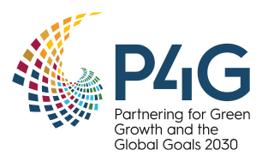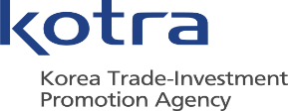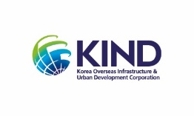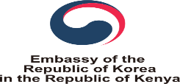

**Re: Invitation to P4G Summit 『KOREA-Africa Green New Deal Project Webinar』**

It is with great pleasure and honor to announce the Online P4G Summit 『Korea-Africa Green New Deal Project Forum』 to be held by Korean Embassy in Kenya on 11th of May, 2021 with the support of KOTRA Nairobi(Korea Trade Centre Nairobi) and KIND(Korea Overseas Infrastructure and Urban Development Corporation) Nairobi Office .

Recently, the Korean government announced the Green New Deal Policy to transform to eco-friendly economy. And May 2021, Korea plans to hold the P4G summit, a platform for mid-sized countries responding to climate change.

**Korea’s Green New Deal aims to achieve net-zero emissions and accelerates the transition towards a low-carbon and green economy.** To this end, the government plans to build eco-friendly energy infrastructures that promote energy saving and an increased use of renewable energy. The mobility, energy, technology and other types of climate-friendly industries will be strengthened in all possible ways.

It is very right time to seek Green New Deal business in Africa as Africa is the market which has one of the most promising and affluent renewable projects.

##### ***P4G*** – **Partnering for Green Growth and the Global Goals 2030** – accelerates pioneering market-based partnerships to build sustainable and resilient economies. We invest in impact to deliver inclusive and tangible solutions to build back better and greener to meet the United Nations Sustainable Development Goals and the Paris Agreement. **The 2021 P4G Seoul Summit will position P4G as a delivery mechanism to build back better and greener in this decade of action**. The P4G Summit is scheduled for May 30 – 31, 2021.

##### ***Green New Deal*** – The Korean New Deal, announced in Korean on July 14 2020, plans to invest 160 trillion won (114.1 trillion won worth of fiscal investment) to create 1,901,000 jobs by 2025 based on two main policies – the Digital New Deal and Green New Deal- and an overarching policy support to strengthen employment and social safety net. **The “green” part of the plan is known as the Green New Deal** (not to be confused with the US’ proposed package of climate policies, of the same name). The Korean green plan involves US$61.9 billion targeting the creation of 319,000 jobs by 2022 and 659,000 by 2025.

I would like to extend a warm invitation to you to attend the P4G Webinar as audience and more than 100 Kenyan and Korean companies at the forefront of innovation are expected to participate in this event to gain invaluable information from P4G summit webinar. I truly believe that participating in this webinar can take advantage of the best and most innovative solutions to understand the landscape of Africa energy market.

This event is planned as the follows:

# Background: P4G Summit will be held in 30th~31st May. In support of this summit, KOTRA opens a webinar to introduce the trends of Africa Green New Deal to Korean partners and stakeholders and to search for opportunity for cooperation

# Main topic: Introducing Africa Green New Deal policies and projects for both Korean and Kenyan stakeholders

# Date: 11th May 2021 (Tuesday) 10:00~12:00AM (4:00~6:00PM in Korea)

# Platform: ZOOM Webinar

# Audiences: (Korea) Companies that is in Africa or planning to invest in Africa (Africa) All interested entrepreneurs and companies

# Host: The Embassy of the Republic of Korea in the Republic of Kenya

# Organizers: KOTRA (Nairobi), Korea Overseas Infrastructure and Urban Development Corporation (KIND)

# Request for Presentation: 20 Minutes presentation on African Renewable Energy Market (Appreciation to be provided)

# Presentation Language: English (Simultaneous translation will be provided)

<Program Outline>

|  |  |  |  |  |  |  |
| --- | --- | --- | --- | --- | --- | --- |
| Date | Time | Contents | | | Remarks | |
| 5.13(목) | ∙(Opening Session) | | | | | |
| 10:00–10 (10‘) | Opening Address | | | The Korean Embassy | |
| 10:10–30 (20‘) | Africa Renewable Energy Market & Project Overview | | | AfDB | |
| 10:30–50 (20‘) | Africa PPP projects overview (Energy Sector) | | | PWC* | |
| 10:50–11:10 (20‘) | **Overview of Africa DFI and Project Investment in Energy sector** | | | **Deloitte\*** | |
| ∙(Sub-Session Seminar) | Sustainable City | Sustainable Financing | Sustainable Food/Agriculture |  |
| 11:10–50 (40‘) | UN Habitat  (Smart City) | KEXIM  (Africa Green EDCF) | WFP  (Africa Smart-Farm) | Runs concurrently |
| 11:10–50 (40‘) | KoTDA  (Konza Smart-city Project) | KIND  (Africa PPP projects) | KOPIA  (Kenya Smart-Farm) |
| 11:50–12:00 (10‘) | Q & A (run by each topics separately) | | |  | |

※ Simultenous translation will be provided

* To be confirmed

Yours faithfully,

Seok HONG

Managing Director

KIND Nairobi