

**Release Date:** FOR IMMEDIATE RELEASE

**Contact:** **K-City Network Secretariat**

|  |  |
| --- | --- |
| Smart City Planning | [kcitynetwork@kindkorea.or.kr](mailto:kcitynetwork@kindkorea.or.kr)  +82-2-6747-7383, +82-2-6747-7387 |
| Smart Solution  Planning/ Demonstration | [kcitysolution@kaia.re.kr](mailto:kcitysolution@kaia.re.kr)  +82-2-798-9725 |

**Homepage:** <http://www.molit.go.kr/english/intro.do>

**The K-City Network Program 2021 starts from February.**

*The procedure for selecting projects(up to 11) for the K-City Network: Global Cooperation Program 2021 will begin on February* *18. The following press release explains the components and schedule of the Program.*

The Ministry of Land, Infrastructure and Transport of the Republic of Korea (MOLIT) will begin the application procedure for the K-City Network: Global Cooperation Program 2021 on February 18.

Last year, Korea launched the K-City Network Program to promote G2G collaboration on smart city and share its experience with countries and cities around the world. The K-City Network 2020 received an overwhelming response with 80 applications submitted by 23 countries. Under the last year’s program, Korea is offering assistance on master plan or feasibility study development for 12 smart city projects in 11 countries.

* Cities selected last year: Kota Kinabalu(Malaysia), Dala(Myanmar), Primorsky Territory (Russia), Mekong Delta Region (Vietnam), Eastern Kalimantan(Indonesia), Cuzco(Peru), Vientiane(Laos), Ulaanbaatar (Mongolia), Bogota (Columbia), Khon Kaen(Thailand), and Gaziantep and Ankara (Turkey)

This year's K-City Network Program has three programs. The Smart City Planning Program is a program for mid-to-large-scale development projects under which Korea provides technical assistance to develop blue prints for the projects. The second, Smart Solution Planning Program, involves development of a smart solution for a city to solve specific urban problems afflicting the city.

Newly added this year is the Solution Demonstration Program. The aim of the program is to introduce Korea’s smart solutions to the countries applying for the program for pilot operation. Details of the three project types are presented below.

1. **Program 1 : Smart City Planning**

The Smart City Planning Program offers a packaged solution to smart city development. The key component of the program is to draft a basic concept, master plan, or feasibility study.

To ensure concrete partnership, applicants eligible for this project will be the central or local governments that will oversee the smart city development projects to be implemented under the Program. Projects under this program will be mid-to-large scale in size like new towns, industrial complexes, or housing blocks.

Examples of such development projects from the K-City Network Program last year include developing ‘Master Plan for the Smart City Development Project for Astete Airport Area in Peru’ and ‘Basic Plan for the Smart City Project for Indonesian New Capital City in Indonesia.’

In 2021, about four smart city development projects will be chosen, considering such factors as project priority in the host country, demand for smart solutions, and opportunities for Korean companies to participate in future projects.

Funding of 400milion to 600milion KRW will be allocated to each project and a framework for cooperation among parties involved will be set up before starting projects.

1. **Program 2 : Smart Solution Planning**

The Smart Solution Planning Program provides an opportunity to design a smart solution tailored to deal with urban problems afflicting a city in areas such as traffic, environment, and energy. Eligible applicants for this program will also be limited to the central or local governments that have jurisdictions over the cities where individual projects will take place and the smart solutions that can be developed under this program include city services or urban systems.

Examples of the program from the K-City Network 2020 include ‘Master Plan for the Smart City Data Coordination Center Establishment Project in Gaziantep (Turkey)’ and ‘Master Plan for the National Intelligent System for Infrastructure, Transit and Transport Establishment Project in Bogota (Columbia).’

Up to four projects will be selected in reflection of such factors as conditions at the project site (whether it has the infrastructure to host smart solutions) and opportunities for Korean companies to participate in future projects. 300 million KRW will be given to each project to draft a plan on smart solution development and adaption. Projects with good study results this year will be preferred if the host governments intend to apply for the Solution Demonstration Program next year.

1. **Program 3 : Smart Solution Demonstration**

The Smart Solution Demonstration Program is a brand new program launched this year to offer Korean companies opportunities to pilot the solutions they developed in countries outside Korea. The smart solutions to be adopted under the program are creations of individual companies or consortium like ‘Smart City Alliance’ and their commercial merits were proven through the Smart Challenge Initiative in Korea.

Given the purpose of the program, cities that meet basic conditions for introducing and running such solutions (e.g. network connection) have higher chances of success. Applicants for this program, unlike the other two, will be the Korean organizations or corporations retaining smart solutions developed in Korea, and they require to form a consortium with an international partner organization for the application.

Each of the three projects selected will be granted 400 million to 600 million KRW to assess the applicability of smart solutions and carry out demonstrations of such solutions. Incentives will be given to the projects that won matching funds from the host governments.

1. **Schedule**

Application period will be between February 18 to April 20, 2021. Application documents can be submitted by post or e-mail*. Selection results will be announced by late June and projects will be implemented up until the first half of 2022 depending on the scale or complexity of projects and the COVID-19 conditions in host countries.

* Recipient: K-City Network Secretariat

Smart City Planning: [kcitynetwork@kindkorea.or.kr](mailto:kcitynetwork@kindkorea.or.kr)

Smart Solution Planning and Demonstration: kcitysolution@kaia.re.kr)

For the Smart City Planning Program and Smart Solution Planning Program, selection procedures will entail evaluation of application documents as well as two-round consultations with the applying governments. As for the Solution Demonstration Program, paper evaluation followed by presentations by the applicants will proceed before selection. After the procedures, selection of the Korean contractors or consultants that will develop basic studies for individual projects will begin.

The public notice on the K-City Network Program 2021 will be published at the web sites of MOLIT ([www.molit.go.kr](http://www.molit.go.kr)) or Smart City Korea ([www.smartcity.go.kr](http://www.smartcity.go.kr)).

1. **Implementation plan**

The K-City Network Program is different from previous overseas development programs as it establishes a concrete cooperation framework before project initiation. This arrangement, by engaging major parties to a project (e.g. Korean government, government of the host country, companies and entities from the public and private sectors) will build solid commitment and create a strong drive to pursue projects.

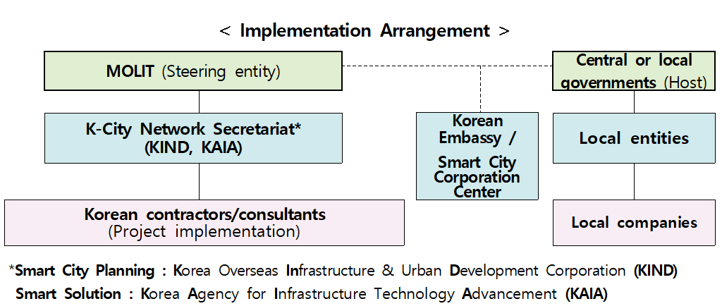

The Program also opens opportunities for further cooperation and investment in future projects. If the results of the basic studies look promising, MOLIT may propose collaboration on the PPP projects based on these studies or offer investment on its own or in partnerships with the MDBs.

Mr. CHOI Im-rak, the Director General for Urban Policy of MOLIT, says, “The K-City Network Program gives Korea a valuable platform upon which we share our smart city development experience and while doing so, provide a catalyst for the Korean companies interested in smart city development projects overseas. Seen from this perspective, addition of the Solution Demonstration Program will give a huge boost to the Korean solution providers in improving and strengthening their market competitiveness.”

